Final SQL Assignment - From Form to SQL: Designing and Analyzing a Complete Data Pipeline

# Data Collection Form

<https://tally.so/r/w2VzBD>

# Submissions from the formScreenshot 2025-04-29 at 20.44.54.pngScreenshot 2025-04-29 at 20.46.05.png

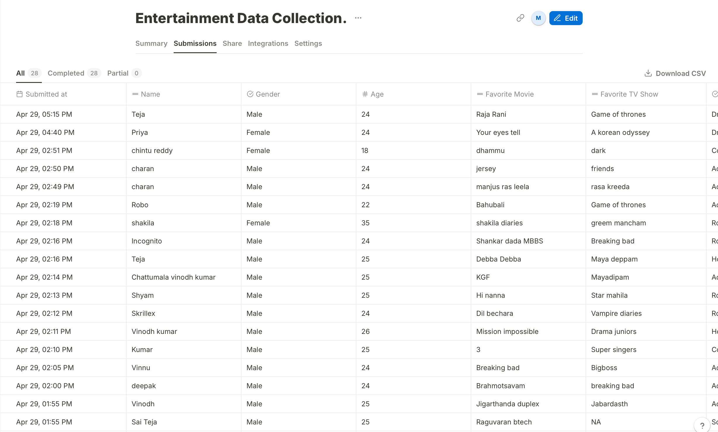

# CSV File used for the projectScreenshot 2025-04-29 at 20.47.39.png

# SQL

I used MySQL Workbench to create a database for this project and used it to create the table and insert the data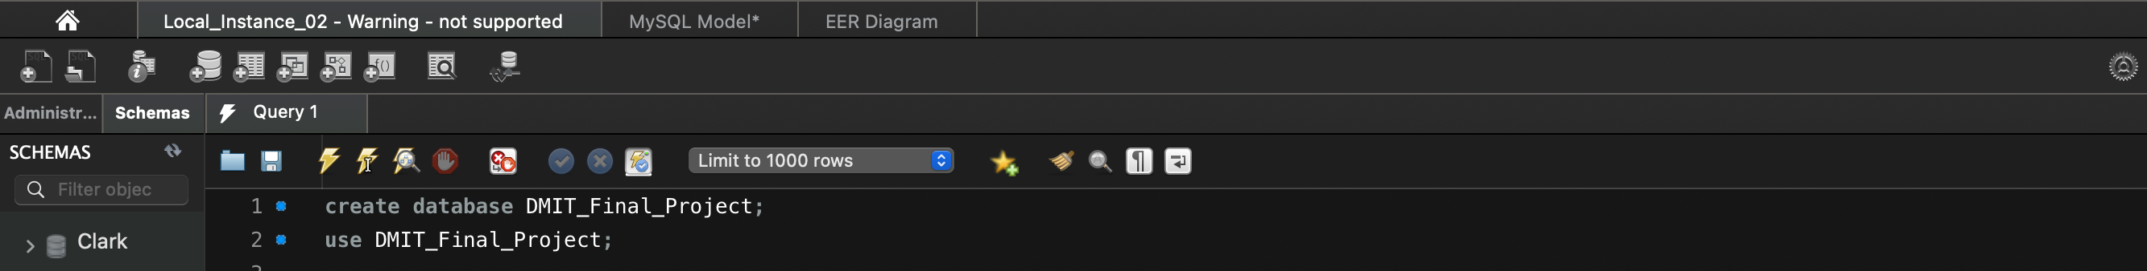

Query :

*create database DMIT_Final_Project;*

use DMIT_Final_Project;

Created table to insert the data according to the CSV file.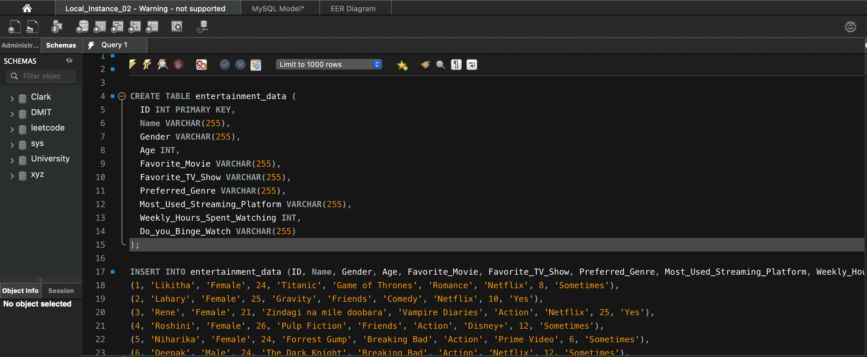

Query :

CREATE TABLE entertainment_data (

ID INT PRIMARY KEY,

Name VARCHAR(255),

Gender VARCHAR(255),

Age INT,

Favorite_Movie VARCHAR(255),

Favorite_TV_Show VARCHAR(255),

Preferred_Genre VARCHAR(255),

Most_Used_Streaming_Platform VARCHAR(255),

Weekly_Hours_Spent_Watching INT,

Do_you_Binge_Watch VARCHAR(255)

);

Normalized into four tables

1. user_profile
2. user_favorites
3. user_streaming
4. user_genre_preference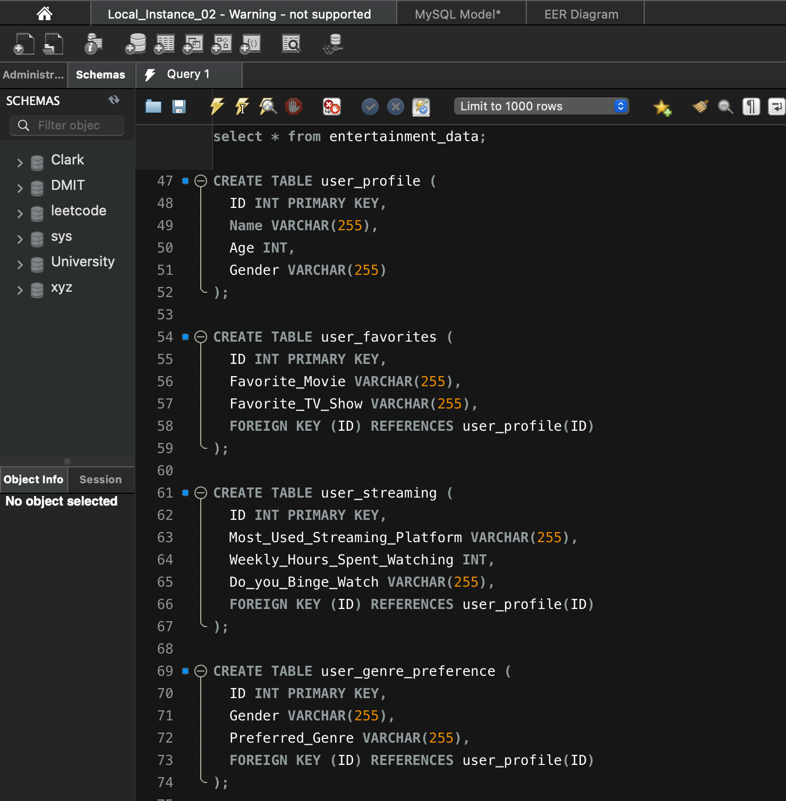

CREATE TABLE user_profile (

ID INT PRIMARY KEY,

Name VARCHAR(255),

Age INT,

Gender VARCHAR(255)

);

CREATE TABLE user_favorites (

ID INT PRIMARY KEY,

Favorite_Movie VARCHAR(255),

Favorite_TV_Show VARCHAR(255),

FOREIGN KEY (ID) REFERENCES user_profile(ID)

);

CREATE TABLE user_streaming (

ID INT PRIMARY KEY,

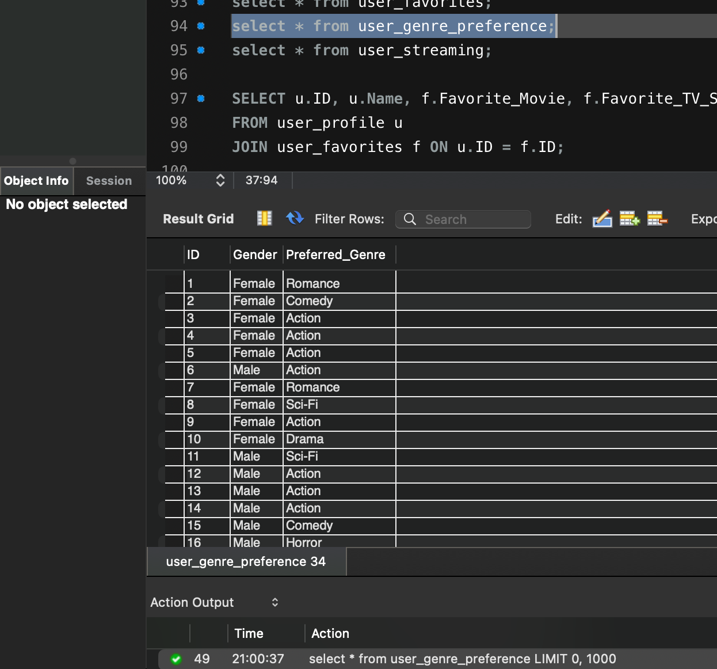Most_Used_Streaming_Platform VARCHAR(255),

Weekly_Hours_Spent_Watching INT,

Do_you_Binge_Watch VARCHAR(255),

FOREIGN KEY (ID) REFERENCES user_profile(ID)

);

CREATE TABLE user_genre_preference (

ID INT PRIMARY KEY,

Gender VARCHAR(255),

Preferred_Genre VARCHAR(255),

FOREIGN KEY (ID) REFERENCES user_profile(ID)

);

# Join Queries

1. SELECT u.ID, u.Name, f.Favorite_Movie, f.Favorite_TV_Show

FROM user_profile u

JOIN user_favorites f ON u.ID = f.ID;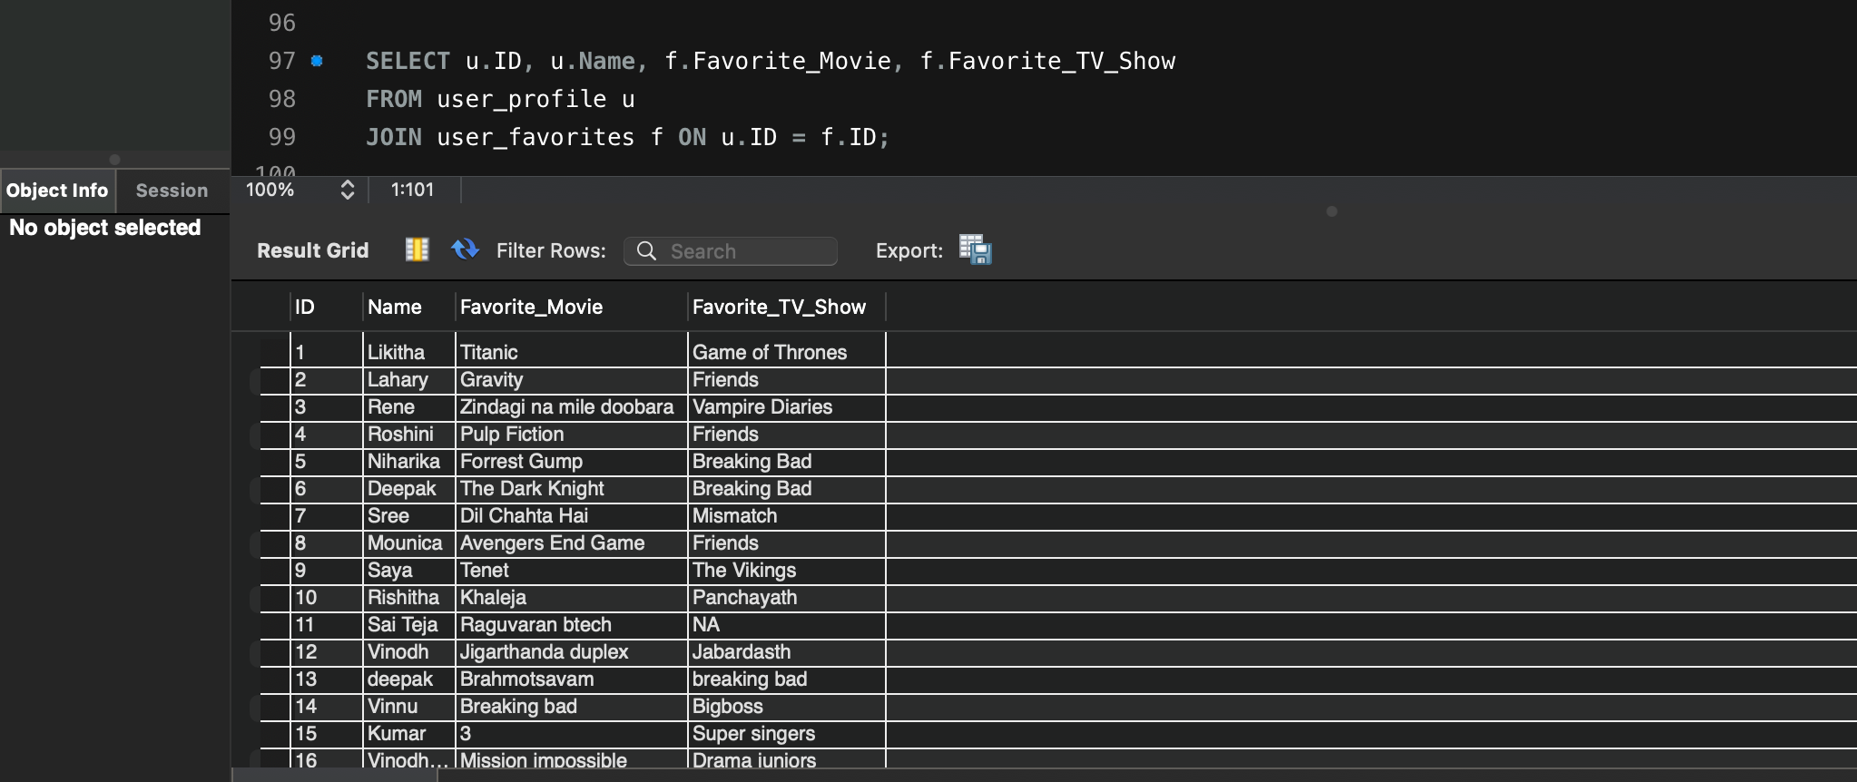

SELECT u.Name, u.Gender, g.Preferred_Genre, s.Most_Used_Streaming_Platform, s.Weekly_Hours_Spent_Watching

FROM user_profile u

JOIN user_streaming s ON u.ID = s.ID

JOIN user_genre_preference g ON u.ID = g.ID;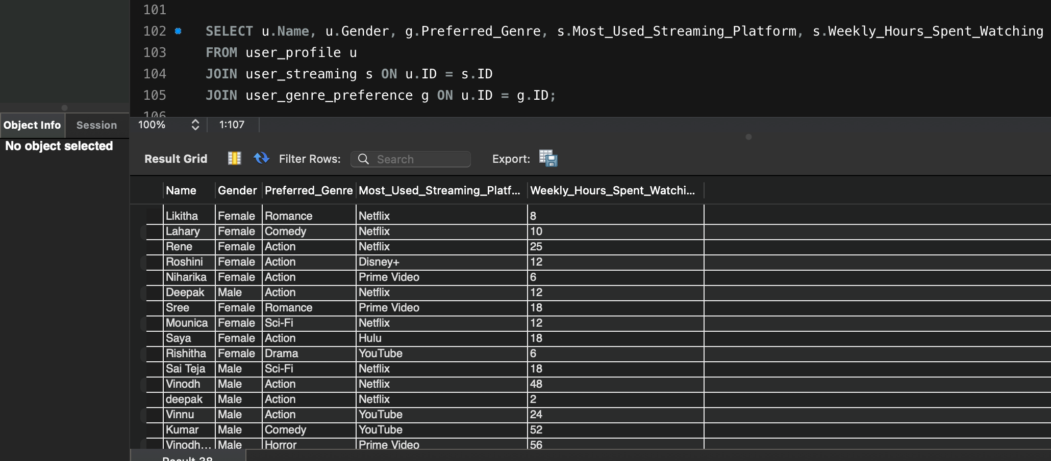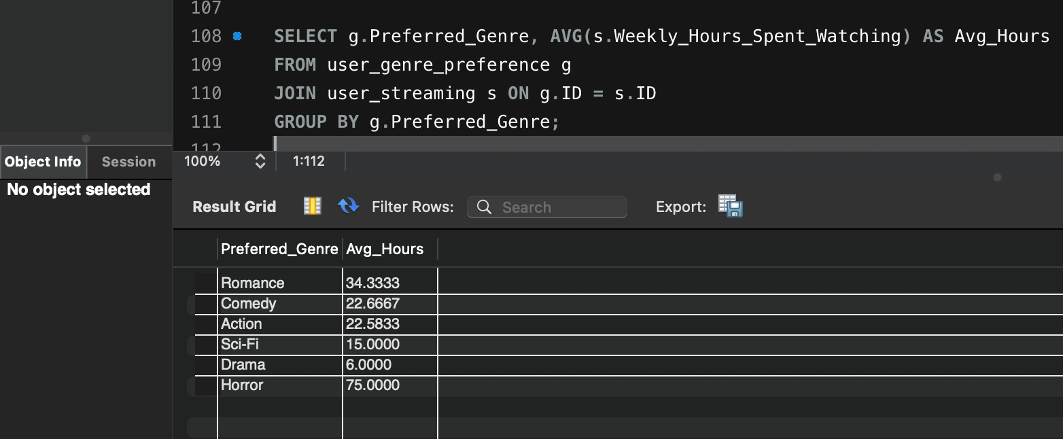

# Group By Query

SELECT g.Preferred_Genre, AVG(s.Weekly_Hours_Spent_Watching) AS Avg_Hours

FROM user_genre_preference g

JOIN user_streaming s ON g.ID = s.ID

GROUP BY g.Preferred_Genre;

# Case Query

SELECT u.Name, s.Weekly_Hours_Spent_Watching,

CASE

WHEN s.Weekly_Hours_Spent_Watching < 10 THEN 'Light Viewer'

WHEN s.Weekly_Hours_Spent_Watching BETWEEN 10 AND 30 THEN 'Moderate Viewer'

ELSE 'Heavy Viewer'

END AS Viewing_Category

FROM user_profile u

JOIN user_streaming s ON u.ID = s.ID;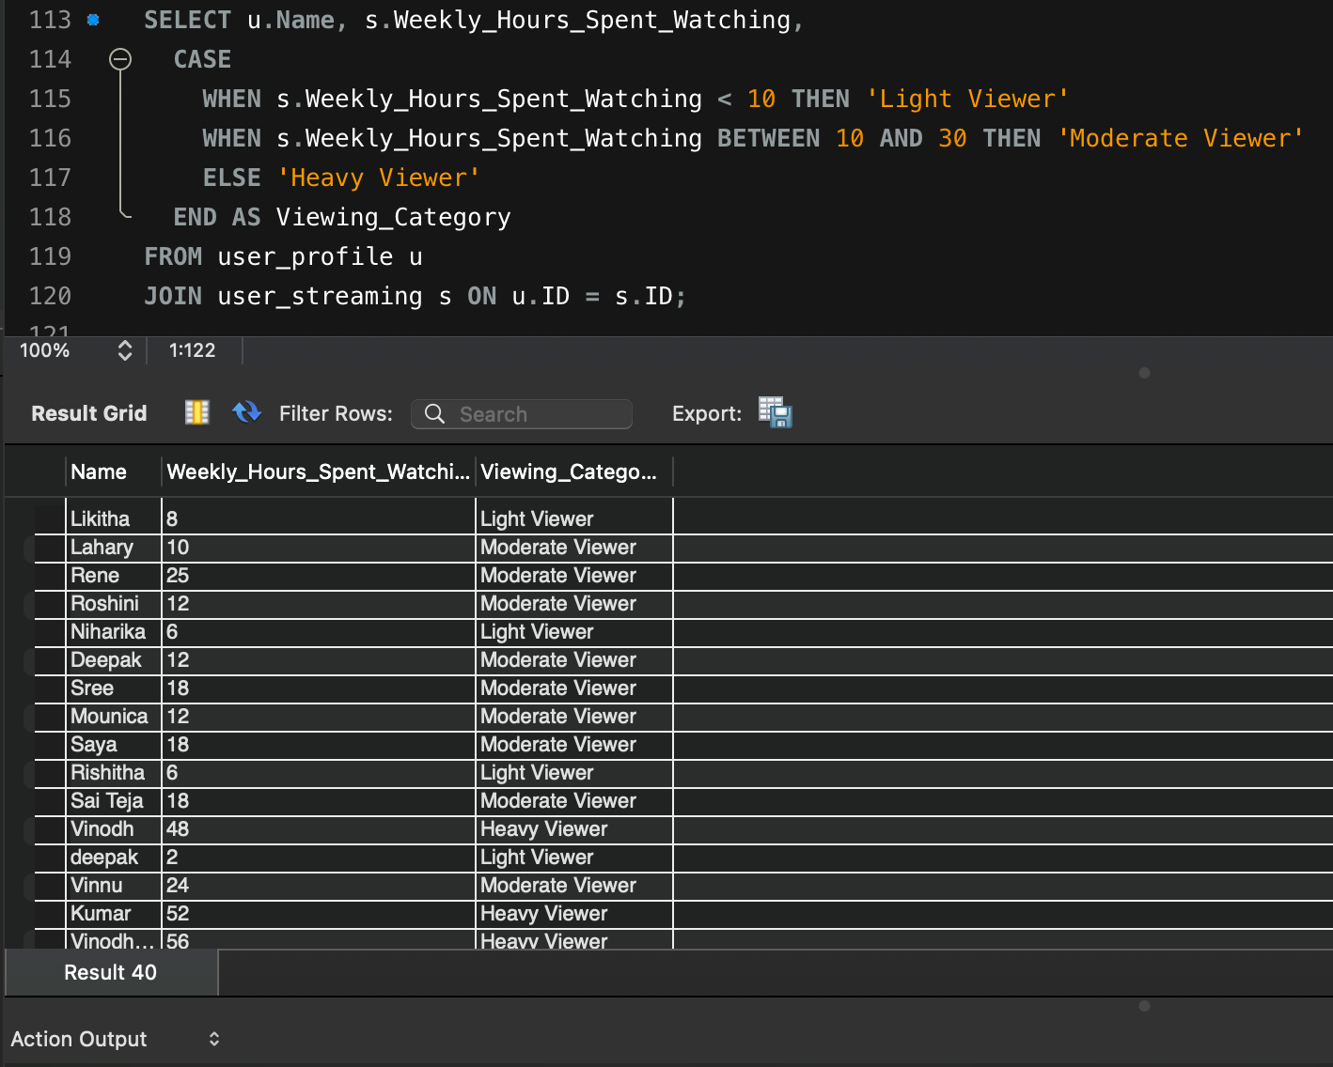

# View Query

CREATE VIEW view_binge_watchers AS

SELECT u.Name, s.Most_Used_Streaming_Platform

FROM user_profile u

JOIN user_streaming s ON u.ID = s.ID

WHERE s.Do_you_Binge_Watch = ‘Yes';

SELECT * FROM view_binge_watchers;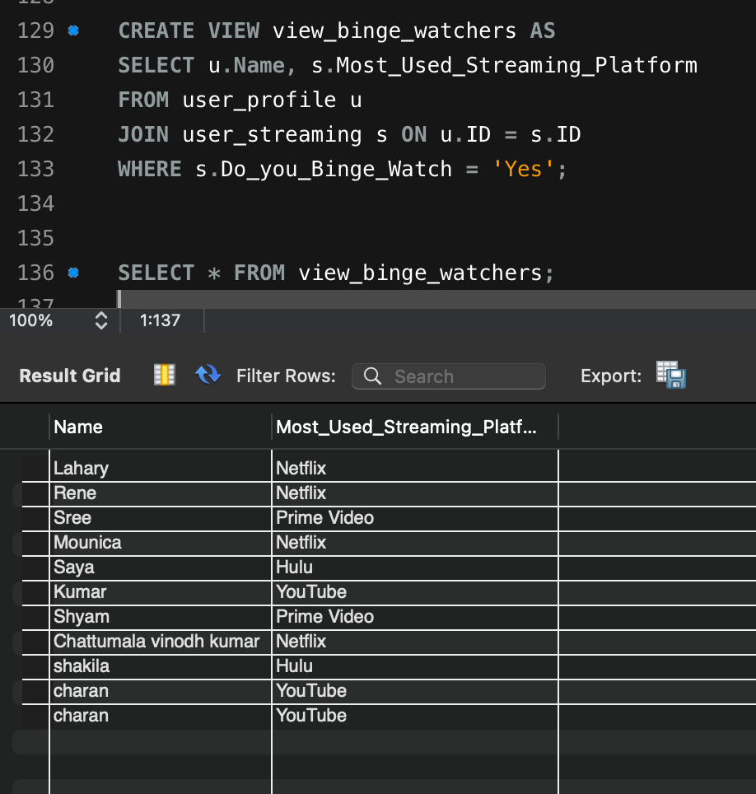

# Analytical Queries

Query1 : SELECT Most_Used_Streaming_Platform, AVG(Weekly_Hours_Spent_Watching) AS Avg_Hours

FROM user_streaming

GROUP BY Most_Used_Streaming_Platform

ORDER BY Avg_Hours DESC;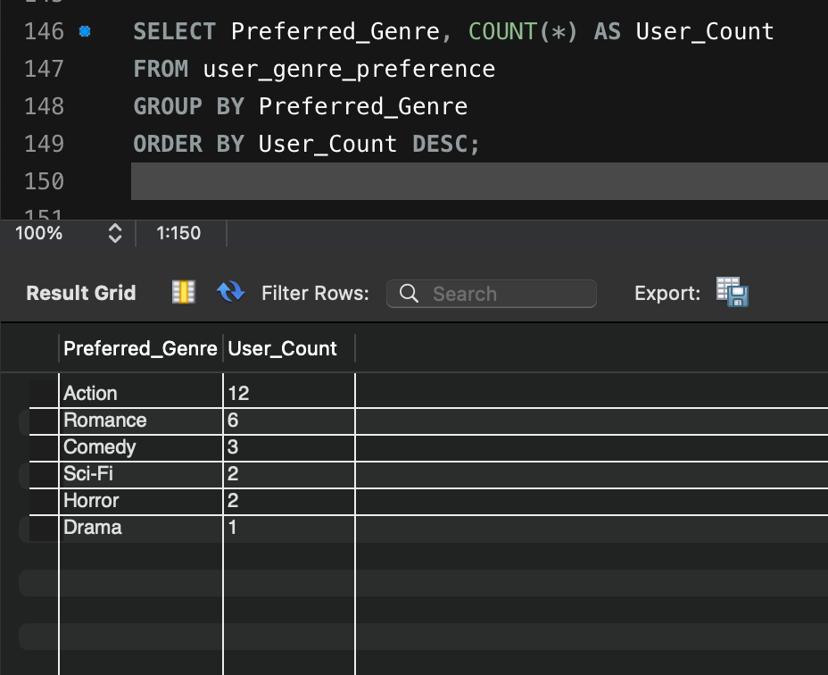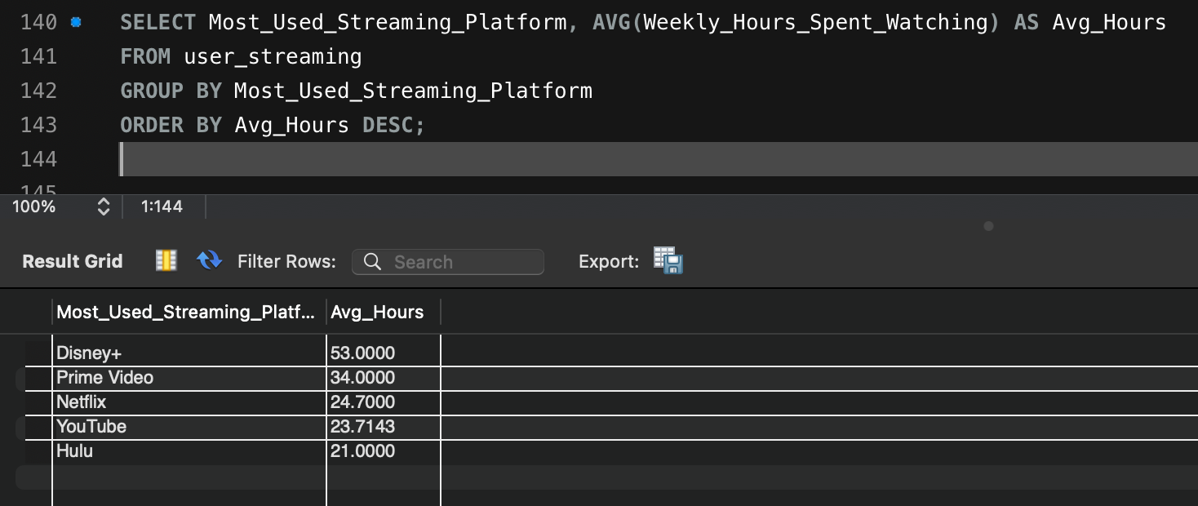

Query2 : SELECT Preferred_Genre, COUNT(*) AS User_Count

FROM user_genre_preference

GROUP BY Preferred_Genre

ORDER BY User_Count DESC;

# PowerBi Dashboard based on the collected data

<https://app.powerbi.com/links/tBTj8iiJxx?ctid=b5b2263d-68aa-453e-b972-aa1421410f80&pbi_source=linkShare>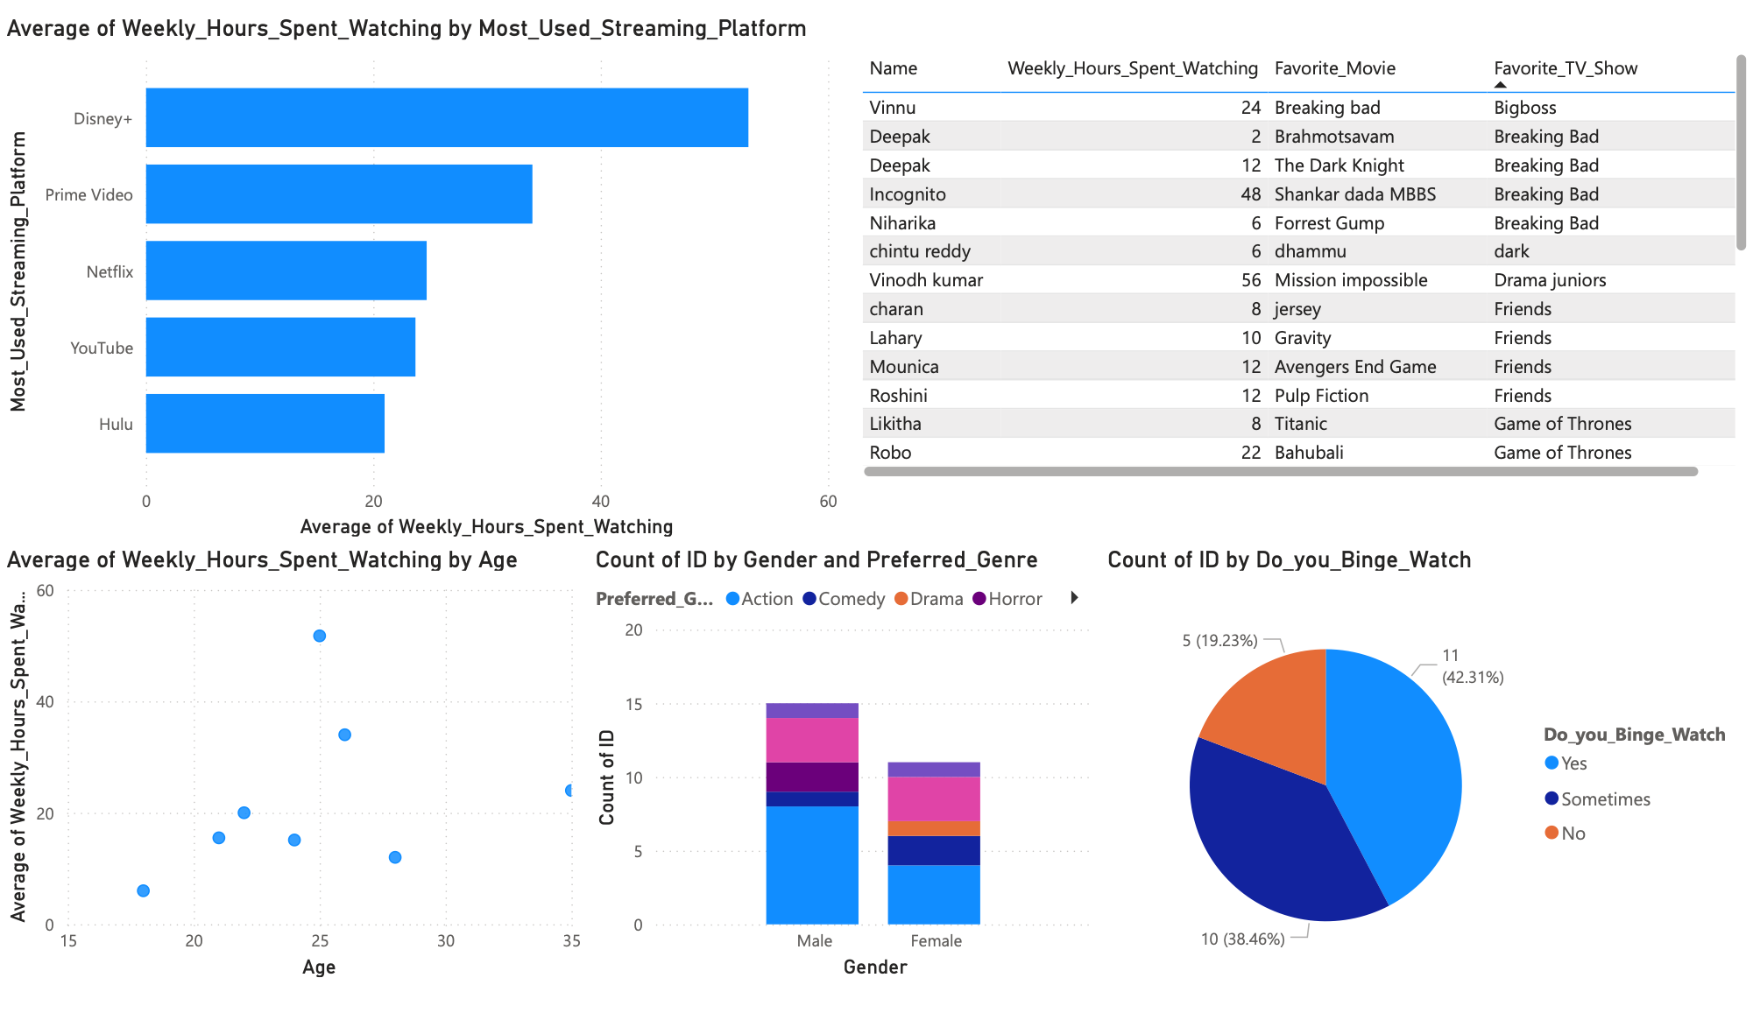

# Final Project Summary

1. What was your topic and goal for the data you collected?

My project focused on analyzing entertainment consumption habits which include binge-watching and streaming services consumption trends. It aimed to figure out how age, gender, preferred genres, and weekly hours of viewing correlate with users’ binge-watching habits through structured data analysis and SQL queries.

1. How did you organize the data into a relational schema?

The information was aggregated in a single flat dataset containing various attributes of the user’s activities and preferences. In order to enhance the maintenance of data organization and reduction of redundancy, I split the previously single table into four relational tables:

* 1. user_profile
  2. user_favorites
  3. user_streaming
  4. user_genre_preference

1. What were your key SQL takeaways?

Through this project, I learned how to

* Use JOIN queries to extract insights across multiple tables.
* Apply GROUP BY with aggregate functions like AVG and COUNT.
* Write conditional logic using CASE statements.
* Create and query VIEWS to encapsulate repeated logic.
* Structure normalized tables and enforce relationships using foreign keys.

1. What challenges did you face during normalization or querying?

When I wanted to create a dashboard I decided to use PowerBi but the interface was so difficult for me to understand and it took me some time to understand. For scatter chart I was not able to give the data for the VALUES field.

1. What would you improve if you repeated this project?

I would do some PowerBi homework to understand how to create meaningful insights with the data I have. There is so much to learn in it. I feel like I didnt use it enough to create the dashboard.